Task 7:

Create a custom docker image for nginx and deploy it using docker-compose, where the volume mount should be at /var/opt/nginx location. Push the created custom docker image to your docker hub.

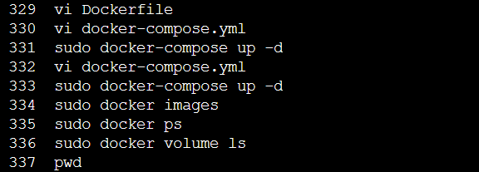

ubuntu@ip-172-31-46-211:~$ sudo docker ps

CONTAINER ID IMAGE COMMAND CREATED STATUS PORTS NAMES

a6bc6dbf13cb task_nginx "/docker-entrypoint.…" About an hour ago Up About an hour 0.0.0.0:1000->80/tcp, :::1000->80/tcp task_nginx_1

759102938a1c wordpress "docker-entrypoint.s…" 3 hours ago Up 3 hours 0.0.0.0:8080->80/tcp, :::8080->80/tcp devops_wordpress_1

6104621b448e mysql:5.7 "docker-entrypoint.s…" 3 hours ago Up 3 hours 3306/tcp, 33060/tcp devops_db_1

ubuntu@ip-172-31-46-211:~$ pwd

/home/ubuntu

ubuntu@ip-172-31-46-211:~$ sudo docker tag task_nginx madhankumarramasamy/test

ubuntu@ip-172-31-46-211:~$ sudo docker push madhankumarramasamy/test:task_nginx

The push refers to repository [docker.io/madhankumarramasamy/test]

tag does not exist: madhankumarramasamy/test:task_nginx

ubuntu@ip-172-31-46-211:~$ sudo docker push madhankumarramasamy/test

Using default tag: latest

The push refers to repository [docker.io/madhankumarramasamy/test]

aa4383155c11: Pushed

0d0e9c83b6f7: Mounted from library/nginx

cddc309885a2: Mounted from library/nginx

c2d3ab485d1b: Mounted from library/nginx

66283570f41b: Mounted from library/nginx

f5525891d9e9: Mounted from library/nginx

8ae474e0cc8f: Mounted from library/nginx

92770f546e06: Layer already exists

latest: digest: sha256:d5df8c29db0020137065df41f398db75c1dfd6c16ef028bcf1967be2414b56e2 size: 1985

ubuntu@ip-172-31-46-211:~$

